# 

Graduation Project

A Comprehensive Solution for Academic Survey Management and Data-Driven Insights

Team Members:

|  |  |  |  |  |
| --- | --- | --- | --- | --- |
| **Student Name** | **Student Academic ID** | **Program** | **Track** | **Role** |
| Abdallah Amir Monir | 221101049 | CS | SE | Frontend |
| Ahmed Abed Haseeb | 221101029 | CS | SE | UI/UX |
| Ahmed Ehab Mohammed | 221101026 | CS | SE | Backend |
| Khaled Saeed Zahran | 221101039 | CS | SE | Backend |
| Mazen Ehab Fathy | 221101055 | CS | SE | UI/UX |

*Project Advisor:*

*Dr. Khaled M. Fouad*

Faculty of Computer Science and Engineering

New Mansoura University

**2024-2025**

# ABSTRACT

*This documentation provides a comprehensive view of the* ***Questionnaire Management System (QMS)****, outlining the purpose, scope, and core components. The* ***QMS*** *is designed to streamline the creation, management, and analysis of questionnaires, offering a user-friendly platform for organizations to gather and analyze feedback efficiently. This system incorporates various modules, including* ***questionnaire creation****,* ***user management****,* ***response handling****,* ***analytics****, and* ***reporting****.*

# ACKNOWLEDGEMENTS

We would like to express our heartfelt gratitude to all those who have supported and guided us throughout the course of this project.

First and foremost, we extend our sincere appreciation to our supervisor, **Dr. Khaled M. Foad**, for his unwavering support, insightful guidance, and constructive feedback. His expertise and encouragement were vital to the successful completion of our project.

We would also like to acknowledge the contributions of our teaching assistants and professors, whose invaluable knowledge and assistance helped us refine our ideas and overcome challenges during the various stages of this project.

Lastly, a special thanks goes to our team members, whose dedication, hard work, and collaboration were the driving forces behind the progress and success of this endeavor. Each member’s unique skills and commitment played an integral role in achieving our goals.

TABLE OF CONTENTS

ABSTRACT 2

ACKNOWLEDGEMENTS 2

LIST OF TABLES 5

LIST OF FIGURES 5

SYMBOLS & ABBREVIATIONS 5

1. INTRODUCTION 6

1.1. Problem Statement 6

1.2. Project Purpose 6

1.3. Project Scope 6

1.4. Objectives and Success Criteria of the Project 6

Objectives: 6

Success Criteria: 7

1.5. Report Outline 7

2. RELATED WORK 7

2.1. Existing Systems 7

2.2. Overall Problems of Existing Systems 8

2.3. Comparison Between Existing and Proposed Method 8

3. METHODOLOGY 8

3.1. Requirement Analysis 8

Functional Requirements: 9

Non-Functional Requirements: 9

3.2. Design 9

3.3. Implementation 10

3.4 Tools and Technology 10

3.5 Design Overview 11

Registration Page 11

Login Page 12

Reset Password Page 13

Dashboard Page 14

Profile Page 15

Create Questionnaire page 16

View Questionnaires Page 17

Create Questionnaire Modules Page 18

View Questionnaire Modules Page 19

Questionnaire View and Response Page 20

View Questionnaire History Page 21

User Management – View Users page 22

User Management – Roles & Permissions Page 23

User Credentials Email 24

3.6 System Architecture 25

UML Diagrams 26

Database Schema 30

Time Plan 31

4. DISCUSSION 32

Addressing the Problem 32

Significance of Results 32

Sources of Error and Anomalies 32

Broader Impacts and Applications 32

5. CONCLUSIONS 33

Key Findings 33

Broader Relevance 33

Future Directions 33

REFRENCES 34

# LIST OF TABLES

Table 1: Comparison of Existing Systems and the NMU QMS.

Table 2: Functional Requirements for NMU QMS.

Table 3: Non-Functional Requirements for NMU QMS.

Table 4: Timetable for NMU QMS.

# LIST OF FIGURES

Figure 1: Tools and technologies for NMU QMS.

Figure 2: Registration Page for NMU QMS.

Figure 3: Login Page for NMU QMS.

Figure 4: Reset Password Page for NMU QMS.

Figure 5: Dashboard Page for NMU QMS.

Figure 6: Profile Page for NMU QMS.

Figure 7: Create Questionnaire page for NMU QMS.

Figure 8: View Questionnaire page for NMU QMS.

Figure 9: Create Questionnaire Modules page for NMU QMS.

Figure 10: View Questionnaire Modules page for NMU QMS.

Figure 11: Questionnaire View and Response page for NMU QMS.

Figure 12: View Questionnaire History page for NMU QMS.

Figure 13: View Users page for NMU QMS.

Figure 14: Roles & Permissions page for NMU QMS.

Figure 15: User Credentials Email for NMU QMS.

Figure 16: Use Case diagram for NMU QMS.

Figure 17: Entity Relationship diagram for NMU QMS.

Figure 18: Class diagram for NMU QMS.

Figure 19: State machine diagram for NMU QMS.

Figure 20: Database Schema for NMU QMS.

Figure 21: Time Plan for NMU QMS.

# SYMBOLS & ABBREVIATIONS

**QMS:** Questionnaire Management System

**NMU:** New Mansoura University

**ERD:** Entity Relationship Diagram

**UML:** Unified Modeling Language

# 1. INTRODUCTION

The **NMU Questionnaire Management System (QMS)** is a comprehensive web-based application designed to streamline the creation, management, and analysis of questionnaires at New Mansoura University. Developed between October 8, 2024, and November 23, 2024, the system aims to facilitate efficient feedback collection and decision-making processes within the academic and administrative departments of the university. It incorporates user-friendly interface and advanced analytics, ensuring accessibility and security for all stakeholders.

## 1.1. Problem Statement

Effective data collection and analysis are critical for informed decision-making within educational institutions. Existing methods at New Mansoura University were inefficient, lacked standardization, and did not offer real-time analytics. This resulted in limited engagement, delays in feedback processing, and insufficient insights for academic and administrative improvements.

## 1.2. Project Purpose

The primary purpose of the **QMS** is to address the challenges associated with traditional feedback collection methods. By leveraging technology, the system ensures secure, scalable, and efficient management of questionnaires, enabling administrators and educators to gather valuable insights with minimal effort.

## 1.3. Project Scope

The scope of the project encompasses:

* Development of a dynamic questionnaire builder with features like conditional logic.
* Implementation of secure user authentication and role-based permissions.
* Integration of analytics and reporting tools for in-depth data analysis.
* Real-time response management and feedback handling.
* Support for future enhancements such as multi-language support and advanced analytics.

## 1.4. Objectives and Success Criteria of the Project

### Objectives:

1. **Streamlined Questionnaire Management:** Provide tools for creating, distributing, and analyzing questionnaires.
2. **Enhanced Security:** Ensure data privacy and secure access using role-based permissions and encryption.
3. **User Engagement:** Offer an intuitive interface to encourage participation from students and staff.
4. **Data-Driven Insights:** Generate actionable insights through advanced analytics and reporting features.

### **Success Criteria:**

* Successful deployment and user acceptance testing of the system.
* Positive feedback from users on the system's usability and effectiveness.
* Achievement of performance benchmarks such as response time and accuracy of analytics.

## 1.5. Report Outline

The report is organized as follows:

* **Abstract:** A concise summary of the project's objectives, methodology, and outcomes.
* **Acknowledgements:** Acknowledgment of contributors and supporters of the project.
* **List of Tables:** Contains all tables within the document.
* **List of Figures:** Contains all figures within the document.
* **Symbols & Abbreviations:** Contains symbols/abbreviations used throughout the document.
* **Table of Contents:** A detailed breakdown of the report's structure and sections.
* **Section 1:** *Introduction*—Introduces the project, problem statement, purpose, scope, objectives, and outline of the report.
* **Section 2:** *Related Work*—Discusses existing systems, their limitations, and compares them to the proposed solution.
* **Section 3:** *Methodology*—Details the project’s requirement analysis, design and implementation along with the dataset and tools.
* **Section 4:** *Discussion*—Analyzes the results, discusses findings, and highlights insights gained.
* **Section 5:** *Conclusions*—Summarizes the project, its outcomes, and potential future work.
* **References:** Lists all the sources and references cited in the report.

# 2. RELATED WORK

## 2.1. Existing Systems

Several questionnaire management systems have been developed to address the need for efficient survey creation, distribution, and analysis in academic and organizational settings. Examples include:

* **Qualtrics**: Widely recognized for its advanced analytics and experience management, Qualtrics supports robust survey logic, branching, and real-time analytics. Its collaborative features and security measures make it ideal for universities and enterprises [1].
* **SurveyMonkey**: Known for its user-friendly interface and diverse question types, SurveyMonkey facilitates survey creation with features like image heat maps and branching logic. However, advanced functionalities often require higher-tier subscriptions [2].
* **QuestionPro**: This platform provides a cost-effective solution for academic institutions, offering advanced survey workflows, collaborative features, and detailed reporting options tailored for large-scale university research [3].
* **LimeSurvey**: Open-source software that enables customizable survey creation with multi-language support and offline data collection capabilities, making it accessible for diverse research needs [4].

## 2.2. Overall Problems of Existing Systems

While these systems are feature-rich, they exhibit certain limitations:

* **Cost**: High subscription fees for advanced features in platforms like **Qualtrics** and **SurveyMonkey** can be prohibitive for smaller institutions [1][2].
* **Complexity**: Some systems, such as **Qualtrics**, require significant training for effective use, which can hinder adoption[1].
* **Limited Customization**: Generic survey platforms often lack domain-specific customizations, which are vital for applications like the **NMU Questionnaire Management System**.
* **Scalability Issues**: Open-source tools like **LimeSurvey** may face scalability challenges for handling large datasets or high response volumes without significant customization[4].

## 2.3. Comparison Between Existing and Proposed Method

The **NMU Questionnaire Management System (QMS)** addresses many limitations of existing platforms by offering a tailored solution for academic environments. **Table 1** illustrates the key differences:

|  |  |  |  |  |  |
| --- | --- | --- | --- | --- | --- |
| **Feature** | **Qualtrics** | **SurveyMonkey** | **QuestionPro** | **LimeSurvey** | **NMU QMS** |
| Cost-Effectiveness | Moderate | High | Low | Free/Low | **Affordable** |
| Domain-Specific Customization | Moderate | Low | Moderate | Low | **High** |
| Collaborative Features | High | Moderate | High | Moderate | **High** |
| Security & Compliance | High | Moderate | High | Moderate | **High** |
| Scalability | High | Moderate | High | Low | **High** |

**Table 1:** Comparison of Existing Systems and the NMU QMS.

The proposed system provides a cost-effective and customizable platform tailored to meet the needs of **New Mansoura University**. By integrating advanced security, real-time analytics, and a user-friendly interface, the **QMS** is well-suited for streamlining questionnaire management and feedback analysis.

# 3. METHODOLOGY

This section outlines the systematic approach taken to develop the NMU Questionnaire Management System, covering requirement analysis, design, and implementation.

## 3.1. Requirement Analysis

The project began with a comprehensive analysis to identify the functional and non-functional requirements for the **NMU Questionnaire Management System**.

### **Functional Requirements**:

|  |  |
| --- | --- |
| **Requirement** | **Description** |
| **User Authentication** | Allow users to register, log in, reset passwords, and manage profiles. |
| **Role-Based Access Control** | Differentiate access levels for administrators, educators, and students. |
| **Dynamic Questionnaire Creation** | Provide features to create questionnaires with multiple question types. |
| **Response Management** | Enable administrators to view and manage questionnaire responses in real time. |
| **Analytics and Reporting** | Generate reports for responses. |

**Table 2:** Functional Requirements for NMU QMS.

### **Non-Functional Requirements**:

|  |  |
| --- | --- |
| **Requirement** | **Description** |
| **Security** | Implement encryption for data at rest and in transit. |
| **Scalability** | Handle increasing numbers of users and responses without performance degradation. |
| **Usability** | Ensure an intuitive interface accessible to users with minimal training. |
| **Reliability** | Provide consistent and error-free operation during peak usage. |
| **Performance** | Ensure fast loading times and low latency for user actions. |
| **Maintainability** | Use modular code and documentation to facilitate updates and troubleshooting. |

**Table 3:** Non-Functional Requirements for NMU QMS.

The requirements were gathered through discussions with stakeholders, including university administrators, educators (TA, Professors, etc.), and IT staff, along with a review of existing systems and their shortcomings ***(as detailed in Section 2).***

## 3.2. Design

The design phase focused on developing a scalable and maintainable architecture. Key components of the system include:

* **System Architecture**:  
  The system follows a **three-tier architecture** comprising:
  + **Presentation Layer**: A web-based user interface designed using **HTML, CSS, JavaScript** and frameworks like **Bootstrap**.
  + **Application Layer**: **A backend built with Laravel (PHP)** to handle business logic and manage communication between layers.
  + **Database Layer**: A **MySQL database** to store user data, questionnaire content, and response analytics.
* **Database Schema**:  
  A **normalized schema** was designed to include tables for users, roles, questionnaires, responses, and analytics. This ensures data integrity and efficient querying.

## 3.3. Implementation

The implementation phase involved coding the system's core functionalities and integrating its components:

* **Frontend Development**:  
  Responsive web pages were developed using **Bootstrap** and **HTML/CSS**, ensuring compatibility with multiple devices and browsers.
* **Backend Development**:  
  **Laravel** was employed to implement features like authentication, questionnaire management, and data validation.
* **Data Storage**:  
  **MySQL** was used to manage relational data with optimized queries for analytics and reporting.
* **Testing**:  
  **Manual tests** were conducted to ensure the reliability of individual components, followed by production environment testing to validate the complete workflow. Testing scenarios included **user authentication, questionnaire creation, and response analytics**.
* **Deployment**:  
  The system was deployed on a **university server on-premise** with **SSH** using **PuTTY** and **HTTPS-enabled endpoints** for secure access.

## 3.4 Tools and Technology

The **NMU Questionnaire Management System** leverages the following technologies:



**Figure 1:** Tools and technologies for NMU QMS.

* **Laravel:** PHP framework for building a scalable and maintainable backend.
* **PHP:** Backend scripting language used for server-side logic and functionality.
* **Bootstrap:** Frontend framework for responsive and mobile-first web design.
* **HTML:** Markup language for structuring the system's web pages.
* **CSS:** Styling language for designing the visual appearance of the user interface.
* **JavaScript:** Programming language for client-side interactivity and dynamic functionality.
* **Git:** Version control system used to track changes and manage the source code effectively.
* **GitHub:** Collaboration platform for code hosting and version control.

## 3.5 Design Overview

This section contains an overview of the system’s core components, highlighting the view and functionality of each component. The system is composed of the following views:

### Registration Page

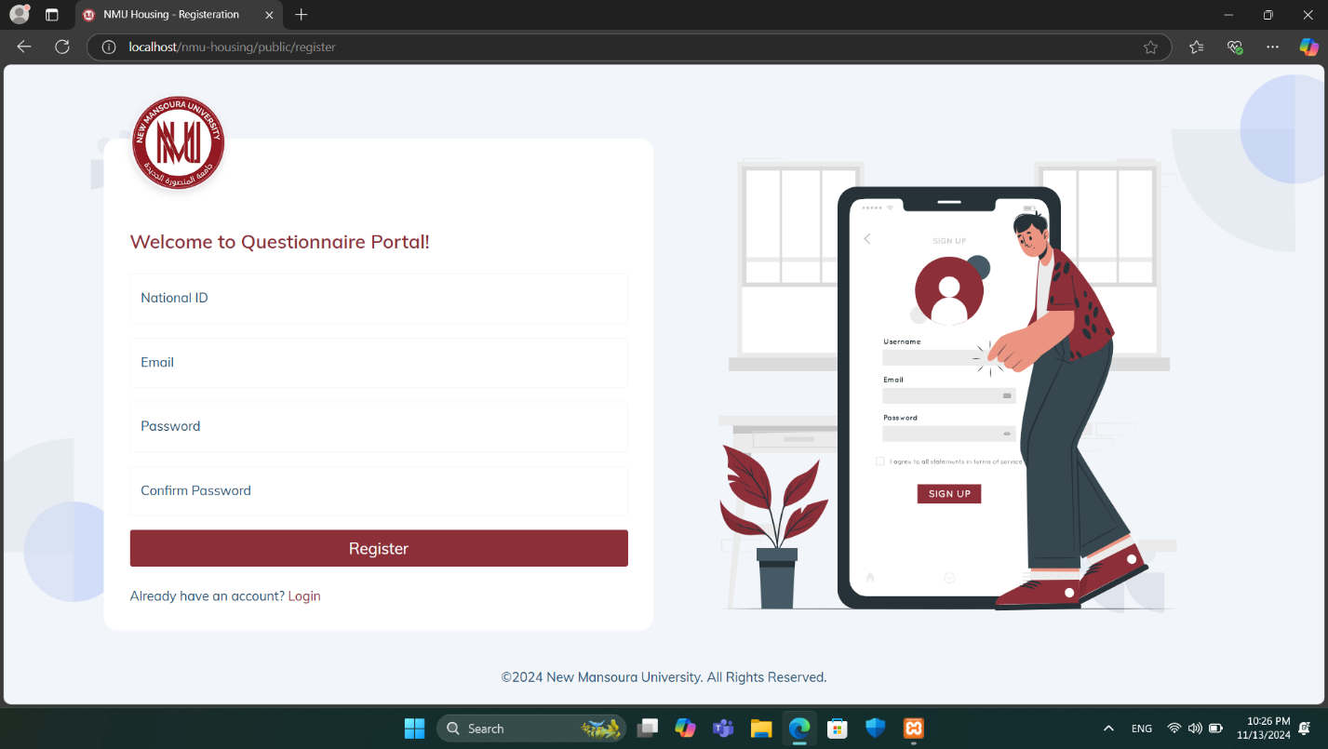

**Figure 2:** Registration Page for NMU QMS.

The **Registration Page** is the entry point for new users to sign up for access to the **NMU Questionnaire Portal**. This page requires users to fill in the following fields:

* **National ID:** A unique identifier required for user verification.
* **Email:** The user's email address, which will be used for communication and login purposes.
* **Password:** A secure password created by the user.
* **Confirm Password:** Ensures accuracy by requiring users to re-enter their password.

After filling out these fields, users can click the **Register button to complete the sign-up process**.

A link below the registration form allows users who already have an account to quickly switch to the Login page. The welcoming design and clear instructions make the sign-up process simple and user-friendly, encouraging ease of access to the questionnaire system.

### Login Page

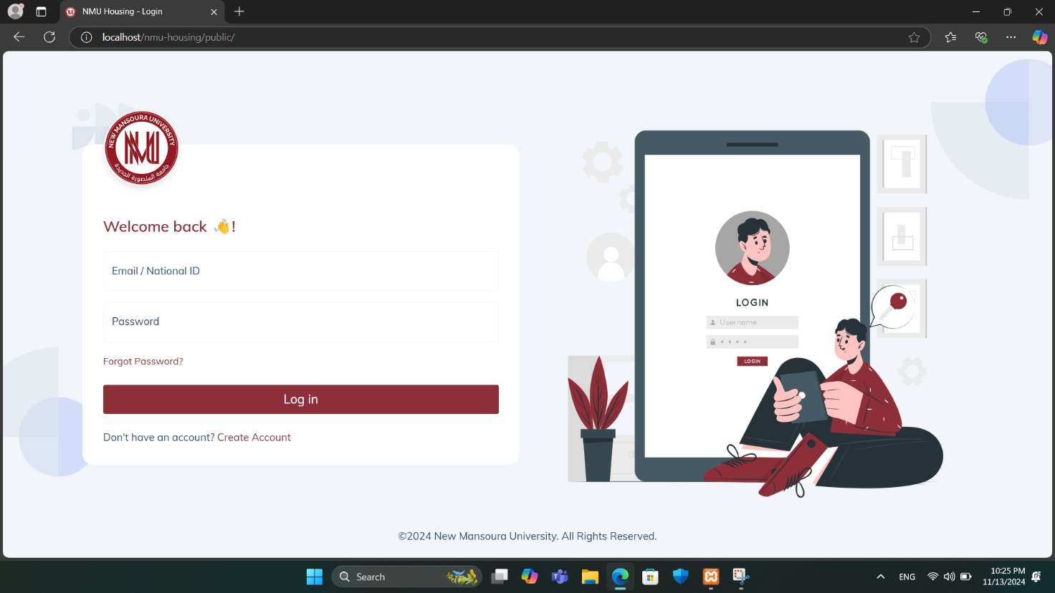

**Figure 3:** Login Page for NMU QMS.

The **Login Page** contains the following:

1. **Logo and Welcome Message**:
   * The New Mansoura University logo is prominently displayed to reinforce brand identity.
   * A welcoming message ("Welcome back!") creates a friendly atmosphere for returning users.
2. **Login Fields**:
   * **Email / National ID**: Field to enter either an email address or a National ID, catering to diverse login preferences.
   * **Password**: Field for users to enter their password securely.
3. **Additional Options**:
   * **Forgot Password?**: A link for users to recover their password if forgotten, improving user experience.
   * **Don’t have an account? Create Account**: A prompt for new users to register for an account if they don't already have one.
4. **Login Button**:
   * A large, clearly visible **Log in** button to submit login credentials and access the system.

### Reset Password Page

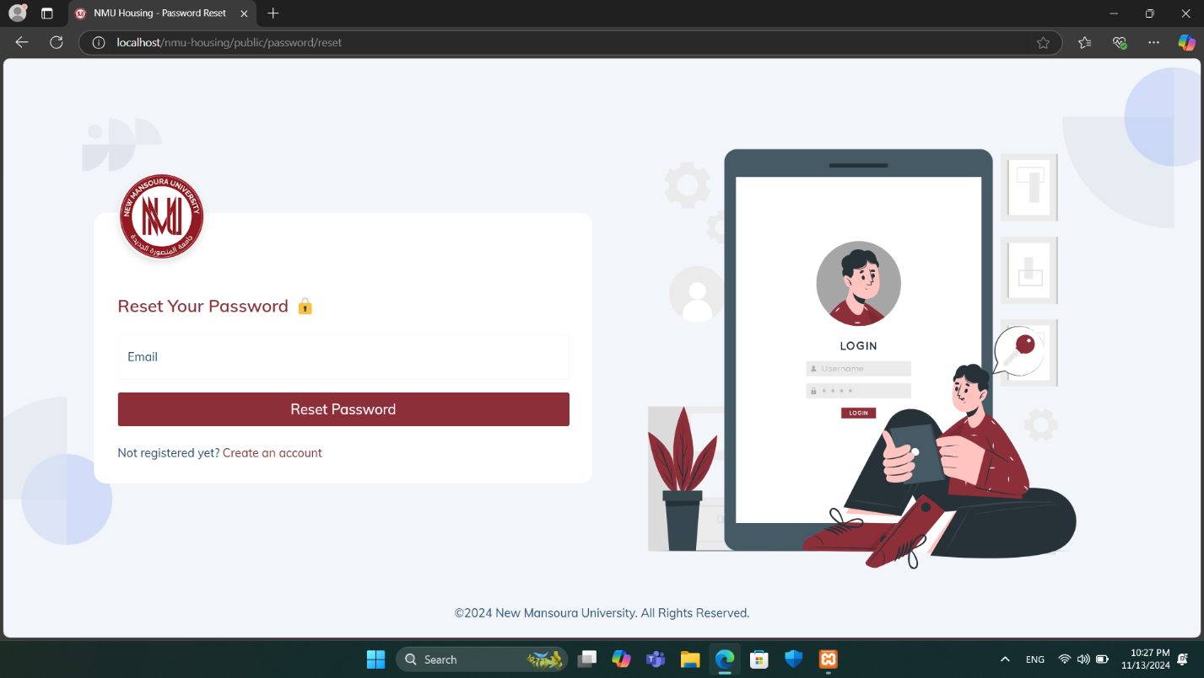

**Figure 4:** Reset Password Page for NMU QMS.

The **Reset Password page** allows users to recover access to their account by requesting a password reset.

* **Email Field:** Users enter the email associated with their account.
* **Reset Password Button:** Initiates the password reset process. Upon clicking, the system verifies the email and, if valid, sends reset instructions to the user’s email.
* **Account Creation Link:** A link for users who are not yet registered, providing a direct path to create an account.

This page ensures a straightforward process for account recovery.

### Dashboard Page

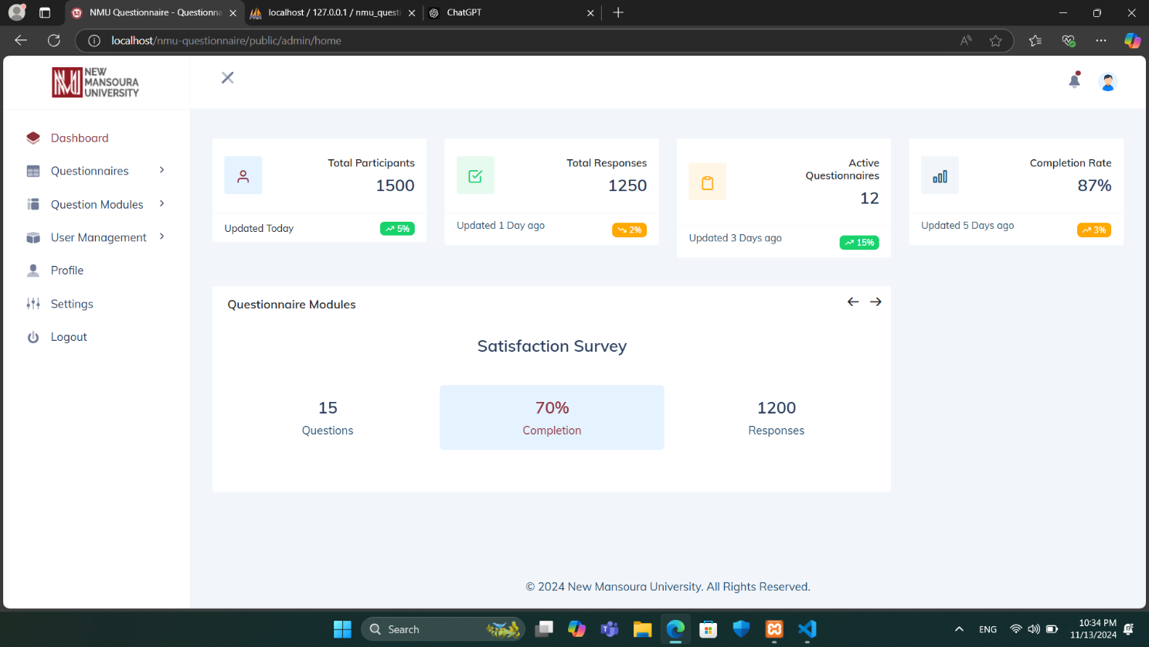

**Figure 5:** Dashboard Page for NMU QMS.

The **Dashboard page** provides an overview of key metrics and statistics related to questionnaires within the system. It includes the following sections:

* **Statistics Summary:** Displays key metrics, including:
* **Total Participants:** Shows the total number of users who participated in questionnaires, with the last update time and recent change percentage.
* **Total Responses:** Indicates the number of questionnaire responses, along with an update timestamp and recent change percentage.
* **Active Questionnaires:** Lists the number of currently active questionnaires, along with recent activity indicators.
* **Completion Rate:** Provides the overall completion rate of questionnaires, showing the percentage and last update details.
* **Questionnaire Modules:** Displays active modules containing preset questions, such as the "Satisfaction Survey." For each module, the system shows the current completion percentage, the number of responses, and the total number of questions. Arrows allow navigation through different modules if multiple sets of preset questions are available.

The left sidebar provides navigation options for accessing other sections, including Questionnaires, Question Modules, User Management, Profile, Settings, and Logout.

### Profile Page

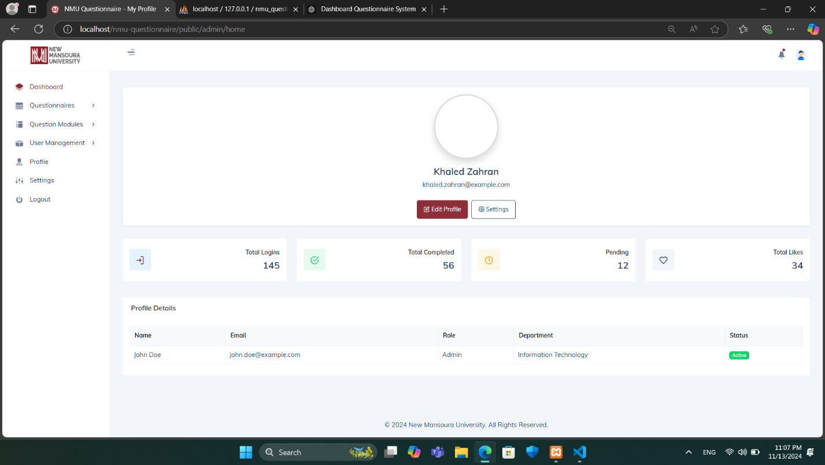

**Figure 6:** Profile Page for NMU QMS.

The **Profile page** provides users with an overview of their account details and activity. At the top, the user’s name and email are displayed, accompanied by options to Edit Profile and access Settings for customization. Below this section, a summary of key metrics is shown, including:

* **Total Logins:** Displays the number of times the user has logged into the system.
* **Total Completed:** Indicates the number of questionnaires or activities completed by the user.
* **Pending:** Shows the count of pending tasks or questionnaires assigned to the user.
* **Total Likes:** Reflects the total likes or approvals received, potentially from other users or administrators.

In the **Profile Details section**, information such as the user’s name, email, role (e.g., Admin), department (e.g., Information Technology), and account status (e.g., Active) is displayed. This provides a quick reference to the user’s role and departmental association within the system.

This page allows users to monitor their engagement within the system and keep track of their profile information and activity status.

### Create Questionnaire page

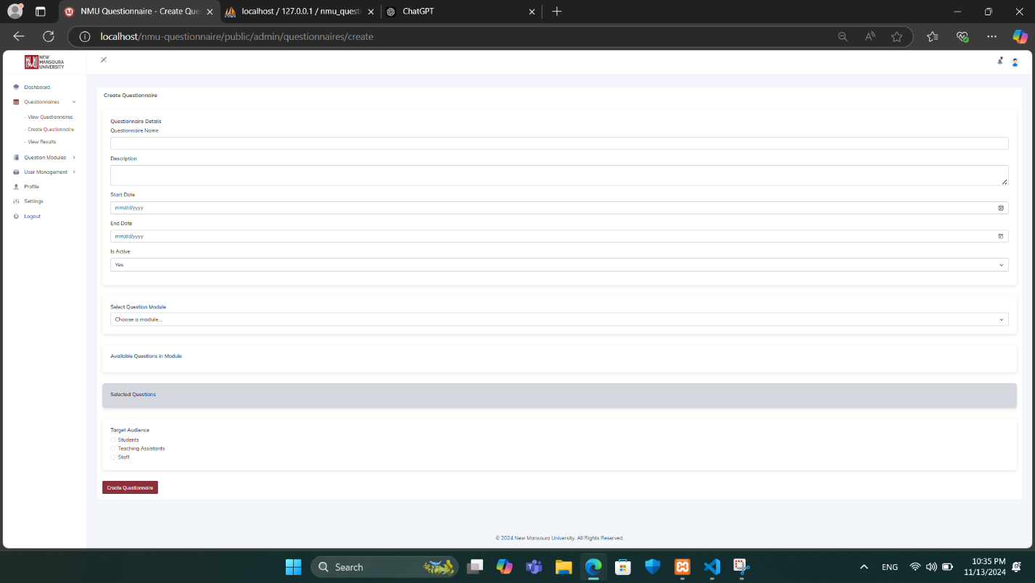

**Figure 7:** Create Questionnaire page for NMU QMS.

The **Create Questionnaire page** contains the following:

1. **Questionnaire Details**:
   * **Questionnaire Name**: Field for entering the name of the questionnaire.
   * **Description**: Field to provide a brief description or purpose of the questionnaire.
   * **Start Date & End Date**: Date pickers to set the active period for the questionnaire, specifying when it will be available to respondents.
   * **Is Active**: Option to toggle the active status of the questionnaire.
2. **Select Question Module**:
   * **Choose a Module**: Dropdown menu to select a preset question module created earlier. This enables the reuse of standardized question sets across multiple questionnaires.
   * **Available Questions in Module**: Displays the questions within the selected module for review.
3. **Selected Questions**:
   * Displays a list of questions selected from the module or added manually.
4. **Target Audience**:
   * Options to select the intended audience for the questionnaire, such as **Students**, **Teaching Assistants**, or **Staff**.
5. **Controls**:
   * **Create Questionnaire**: Button to save and deploy the questionnaire with the selected modules and settings.

This page enables administrators to customize questionnaires based on specific objectives, target audiences, and timelines, making it easier to manage diverse survey requirements.

### View Questionnaires Page

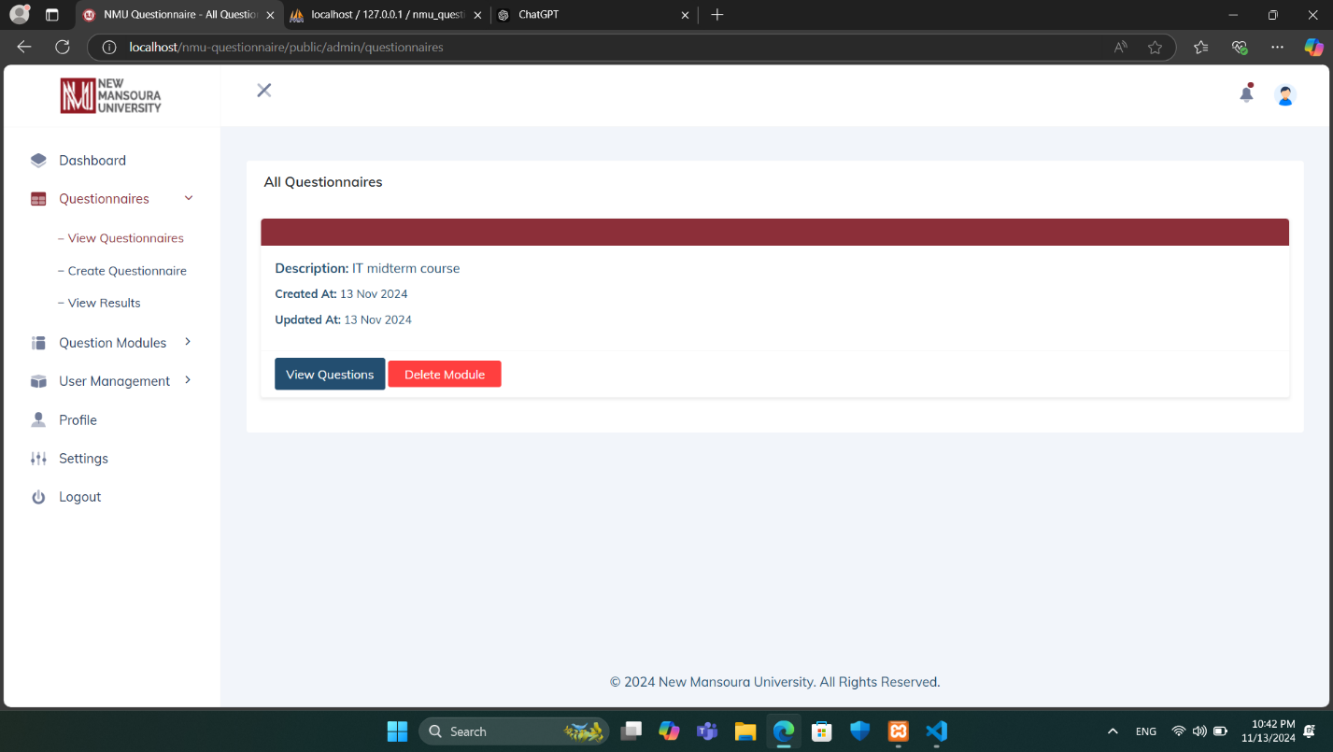

**Figure 8:** View Questionnaire page for NMU QMS.

The **View Questionnaires page** provides a comprehensive list of questionnaires available within the system. Each questionnaire entry displays key information, including a brief Description (e.g., "IT midterm course") and the dates when it was Created and Updated.

For each questionnaire, users have two primary actions available:

* **View Questions:** Opens the questionnaire for a detailed view of all questions included within this specific module.
* **Delete Module:** Permanently removes the questionnaire from the system.

The left sidebar offers quick navigation to other areas of the application, including Questionnaires (for viewing, creating, and analyzing results), Question Modules, User Management, Profile, Settings, and the option to Logout.

This page is particularly useful for administrators and educators to manage and track questionnaires efficiently, ensuring that they can access, update, or delete questionnaires as needed.

### Create Questionnaire Modules Page

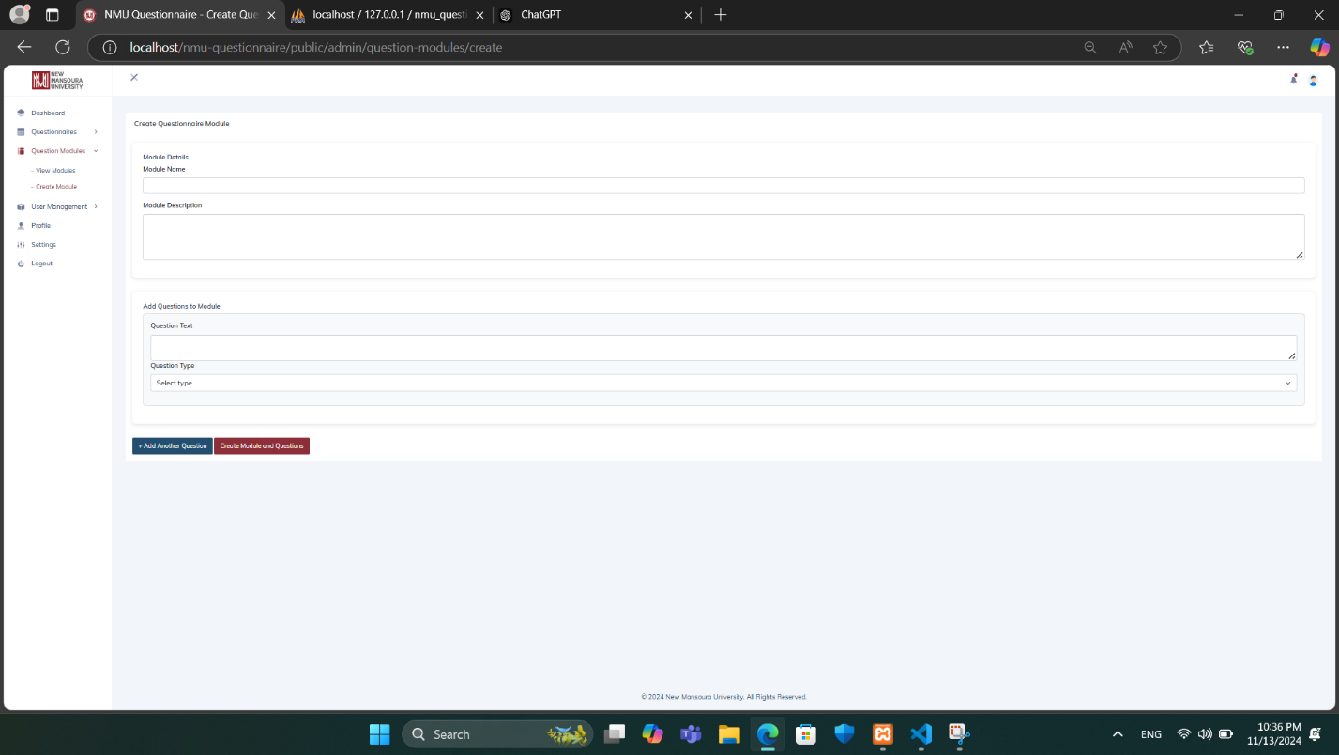

**Figure 9:** Create Questionnaire Modules page for NMU QMS.

The **Create Questionnaire Modules** **page** contains the following **Module Details**:

* **Module Name:** Field for naming the module to describe its purpose (e.g., "Course Feedback").
* **Module Description:** Field to provide additional context about the module.
* **Add Questions to Module:** Button to add questions to the module.
* **Question Text:** Field to enter the text of each question to be included in the module.
* **Question Type:** Dropdown menu to select the type of question (e.g., multiple-choice, short answer, rating scale).
* **Create Module and Questions:** Button to save the module and its questions, making it available for use in questionnaires.

This page is designed to streamline the creation of standardized question sets, facilitating easier and more consistent questionnaire building.

### View Questionnaire Modules Page

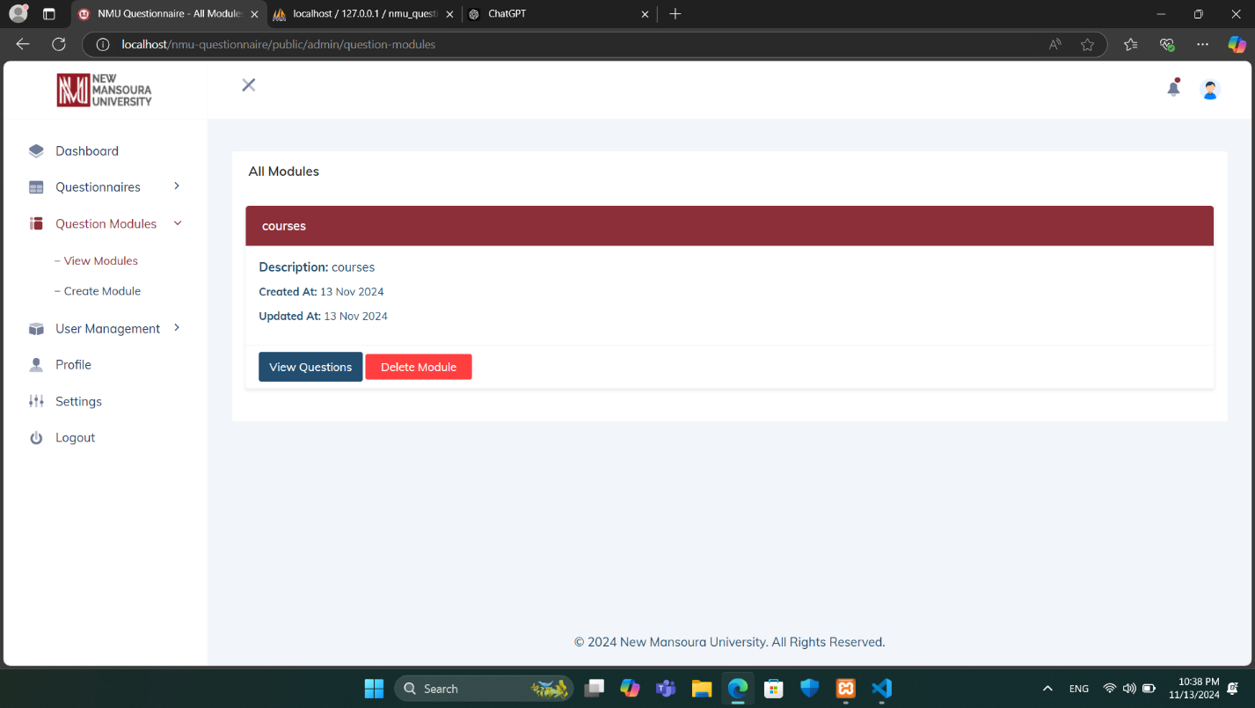

**Figure 10:** View Questionnaire Modules page for NMU QMS.

The **View Questionnaire Modules** page within the **Question Modules** section provides administrators with an organized view of available questionnaire modules in the system.

In the main panel, each module is displayed with the following details:

* **Title**: The name of the module, shown prominently in a red header for clear identification.
* **Description**: A brief description summarizing the purpose of the module.
* **Created At**: The date when the module was created.
* **Updated At**: The date of the last update to the module.

For each module, administrators have two main options:

* **View Questions**: This button allows the administrator to view all questions associated with the selected module.
* **Delete Module**: This button enables the administrator to remove the module from the system.

This page serves as a centralized interface for administrators to manage questionnaire modules, ensuring streamlined access to module details and maintenance options.

### Questionnaire View and Response Page

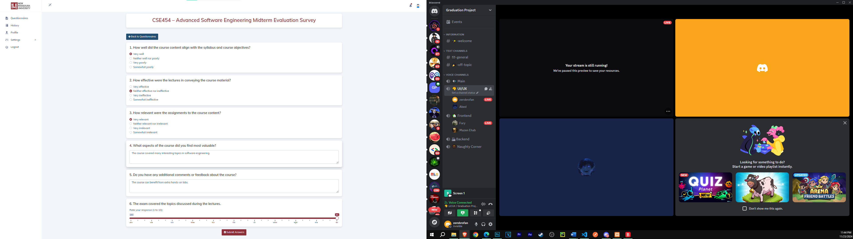

**Figure 11:** Questionnaire View and Response page for NMU QMS.

The **Questionnaire View and Response Page** allows users to participate in and respond to a survey that has been created. The layout of the page is structured for ease of use and clarity:

1. **Header Section**:
   * The title of the questionnaire is prominently displayed, including the course name and survey type (e.g., "CSE454 – Advanced Software Engineering Midterm Evaluation Survey").
   * A navigation button ("Back to Questionnaires") is available for returning to the main questionnaire list.
2. **Questionnaire Content**:
   * The survey consists of multiple questions, presented in a clean, card-like format.
   * Questions include various formats, such as:
     + **Multiple-choice**: Options are displayed with radio buttons for selecting a single response.
     + **Text fields**: Open-ended questions allow users to provide feedback or comments.
     + **Slider scales**: Users can rate their responses on a numeric scale (e.g., 0–10) with a draggable slider for precise input.
3. **Interaction**:
   * Each question is spaced adequately to ensure readability and smooth navigation.
   * Input fields and selection options are intuitive and responsive.
   * **Submit Answers:** Finalizes the responses and submits them.

This page is designed to provide a seamless experience for users to interact with and complete surveys efficiently, supporting both structured and open-ended feedback collection.

### View Questionnaire History Page

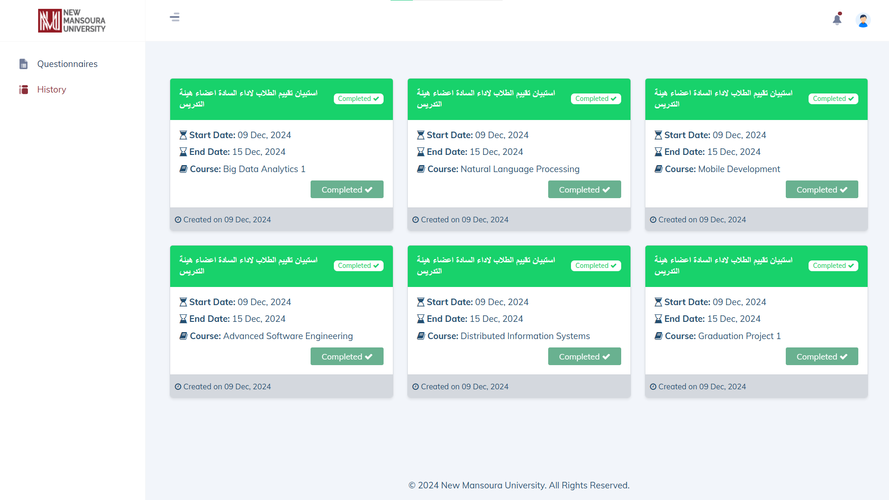

**Figure 12:** View Questionnaire History page for NMU QMS.

The **View Questionnaire History** page provides users with an overview of completed evaluations for various courses. This page is designed to provide concise and organized details for easy access and reference.

At the top of the page, a list of completed questionnaires is displayed, with each card containing the following information:

* **Title:** The title of the questionnaire, indicating the type of evaluation, such as student evaluation of faculty performance.
* **Start Date:** The date when the questionnaire was made available to students.
* **End Date:** The deadline for completing the questionnaire.
* **Course:** The course associated with the questionnaire, such as "Big Data Analytics 1" or "Mobile Development."
* **Status:** A "Completed" label indicating that the evaluation has concluded and has been taken.

Each card also includes the creation date for further reference. The cards are color-coded with a green header to denote completed questionnaires, offering a clear visual cue for their status.

This page allows users to efficiently track and review the history of questionnaire evaluations, contributing to streamlined feedback management and academic performance monitoring.

### User Management – View Users page

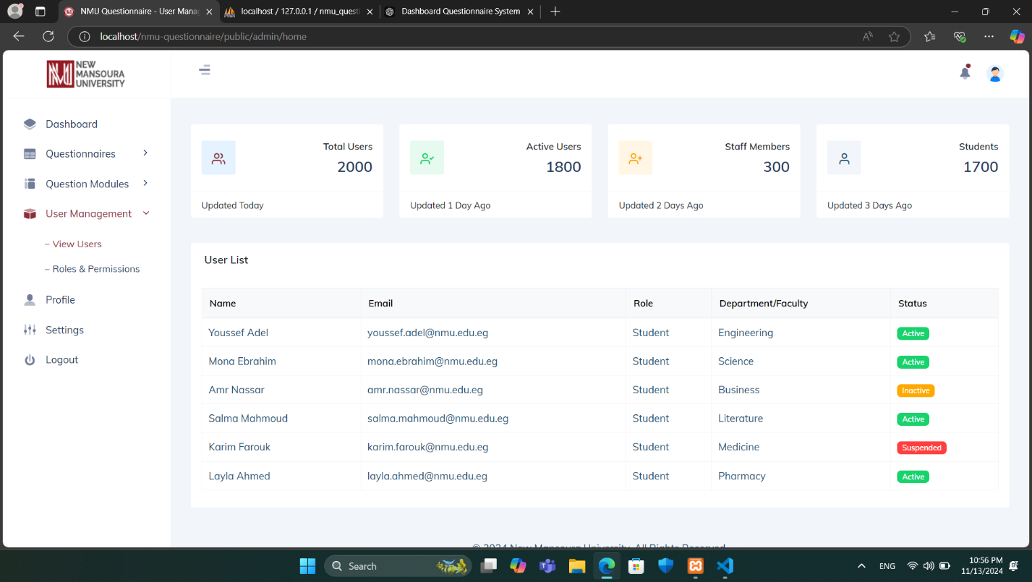

**Figure 13:** View Users page for NMU QMS.

The **View Users page** within **User Management** provides administrators with an overview of system users and key statistics. **At the top of the page, a series of summary cards display:**

* **Total Users:** The total number of users registered in the system.
* **Active Users:** The count of users who are currently active.
* **Staff Members:** The number of users who are staff members.
* **Students:** The count of users identified as students.

**Each card includes the date of the last update for reference.**

Below the summary, the **User List table** provides a detailed view of individual users. The table displays information such as:

* **Name:** The user’s name.
* **Email:** The user’s email address.
* **Role:** The role assigned to the user, such as “Student” or “Staff.”
* **Department/Faculty:** The department or faculty associated with the user.
* **Status:** The current status of the user, displayed as color-coded labels for easy identification, including “Active” (green), “Inactive” (yellow), and “Suspended” (red).

This page allows administrators to monitor and manage user information at a glance, helping maintain an organized and secure system.

### User Management – Roles & Permissions Page

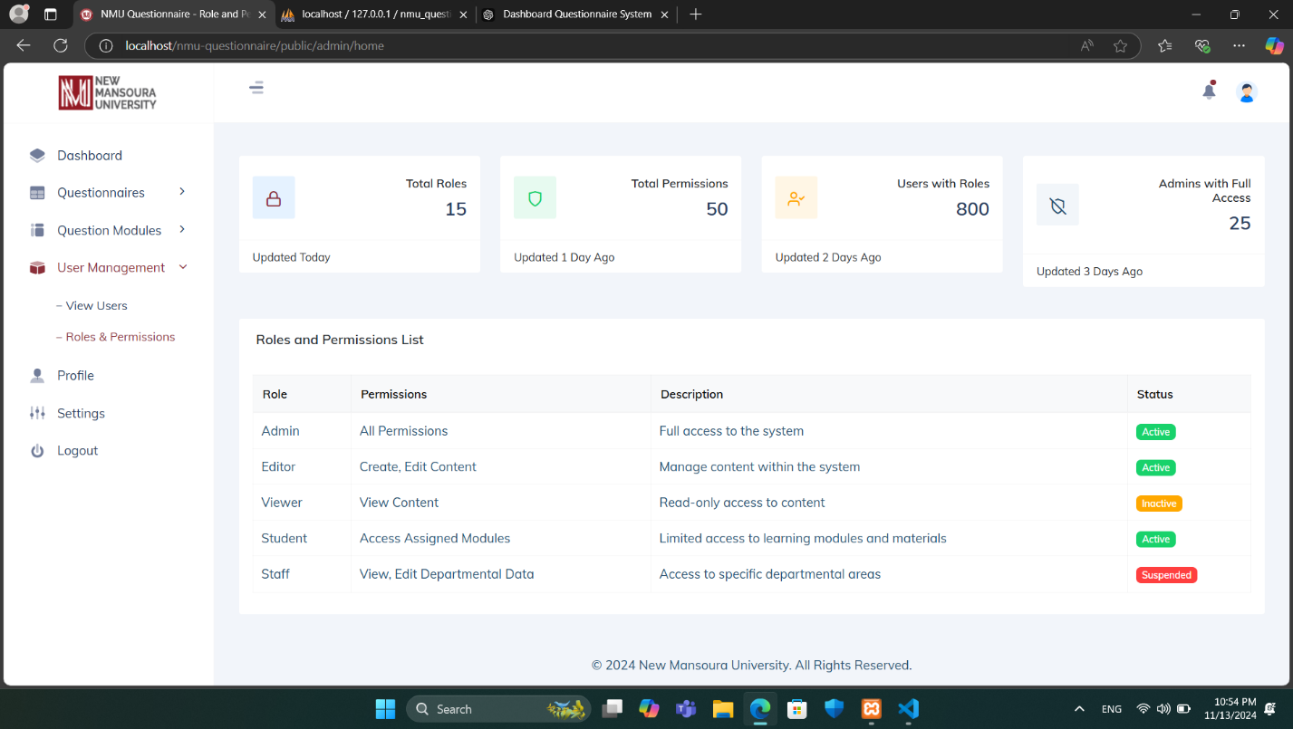

**Figure 14:** Roles & Permissions page for NMU QMS.

The **Roles and Permissions page** within **User Management** provides an overview of user roles within the system, along with their associated permissions and statuses. Key components of this page include:

* **Total Roles:** Displays the total number of unique roles in the system.
* **Total Permissions:** Shows the total number of distinct permissions assigned across roles.
* **Users with Roles:** Indicates the total number of users with assigned roles.
* **Admins with Full Access:** Shows the number of administrators who have full system access.
* **Role:** Lists different roles, such as Admin, Editor, Viewer, Student, and Staff.
* **Permissions:** Describes the permissions associated with each role, such as full access, content editing, view-only access, or access to specific modules.
* **Status:** Indicates the current status of each role (e.g., Active, Inactive, Suspended).

This page helps administrators manage and maintain system security by defining role-based permissions.

### User Credentials Email

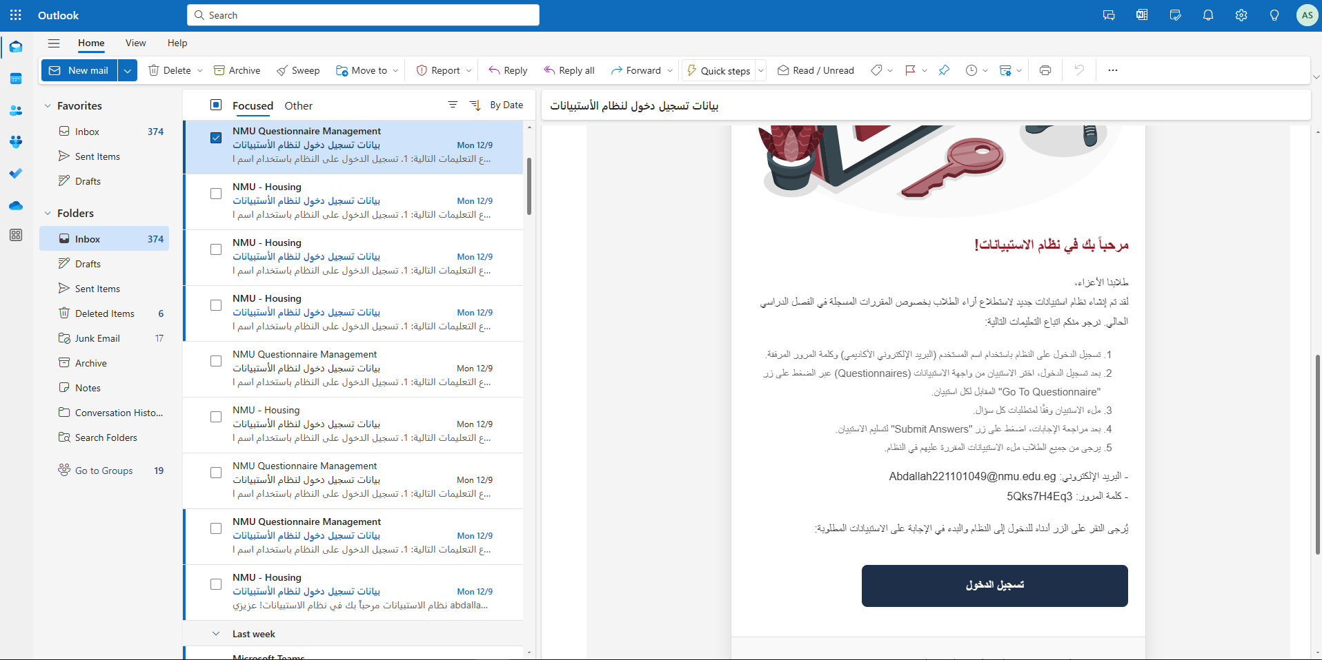

**Figure 15:** User Credentials Email for NMU QMS.

The **User Credentials Email** feature facilitates secure and efficient distribution of login credentials to students through their academic email addresses. This automated email includes the following components:

1. **Welcome Message**:  
   A greeting introducing students to the platform and explaining its purpose.
2. **Login Credentials**:
   * **Username**: The student's academic email address.
   * **Password**: A unique, system-generated password (hashed for security) containing 9 characters.
3. **Step-by-Step Instructions**:  
   Clear guidance on how to log in and use the platform, including navigating to the questionnaire section and submitting answers.
4. **Call to Action**:  
   A prominent "Login" button for easy access to the platform.
5. **Security and Support**:
   * A reminder to keep credentials confidential.
   * Contact information for support in case of login issues.

**Key Features**:

* Dynamic fields ensure each email is tailored to the recipient.
* Secure password handling practices to protect student data.

This feature ensures a seamless onboarding experience for students, aligning with institutional standards for professionalism and security.

## 3.6 System Architecture

The system architecture for the **NMU Questionnaire Management System** is designed to provide a robust, scalable, and user-friendly platform for managing questionnaires. This section outlines the key structural components and their interactions, supported by diagrams that illustrate various aspects of the system.

The architecture is divided into several layers to ensure maintainability and scalability:

* **Use Case Diagram**: This diagram provides a high-level view of the interactions between users (e.g., administrators, educators, students) and the system. It highlights the primary functionalities, such as user authentication, questionnaire creation, and response analysis.
* **Entity-Relationship Diagram (ERD)**: The ERD visualizes the logical structure of the database, showcasing how data entities like users, questionnaires, and responses are interconnected.
* **Database Schema**: The schema details the physical structure of the database, specifying tables, fields, and relationships to support data storage and retrieval.
* **State Machine Diagram**: This diagram represents the dynamic behavior of the system by mapping various states (e.g., questionnaire creation, response submission) and transitions triggered by user actions or system events.
* **Class Diagram**: The class diagram models the static structure of the system, illustrating the main classes, attributes, methods, and relationships within the codebase.

**The following is an overview of the system architecture’s UML diagrams and database schema**:

### UML Diagrams

#### Use Case Diagram

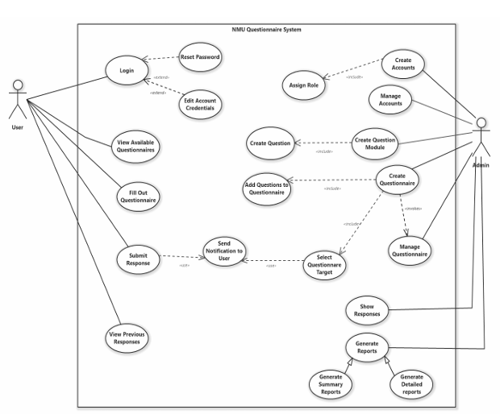

**Figure 16:** Use Case diagram for NMU QMS.

#### Entity Relationship Diagram (ERD)

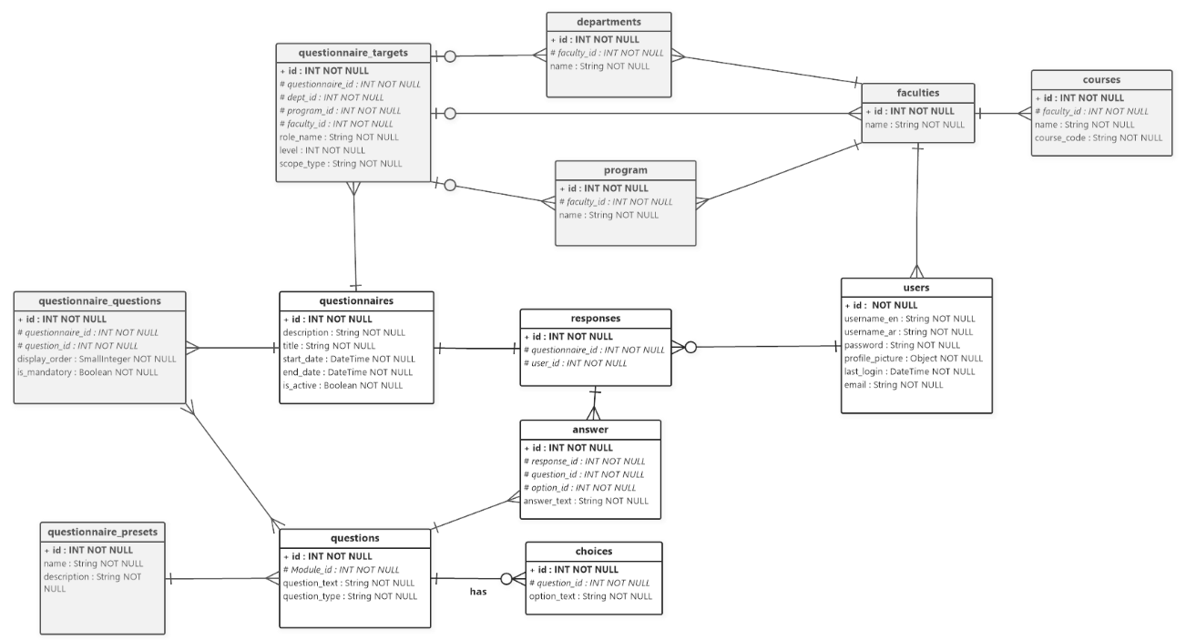

**Figure 17:** Entity Relationship diagram for NMU QMS.

#### Class Diagram

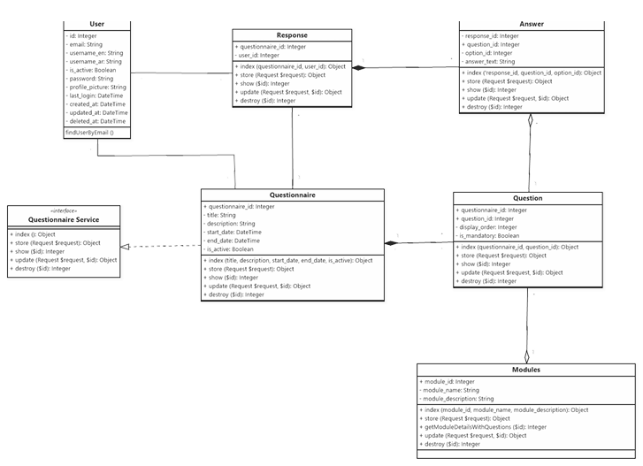

**Figure 18:** Class diagram for NMU QMS.

#### State Machine Diagram

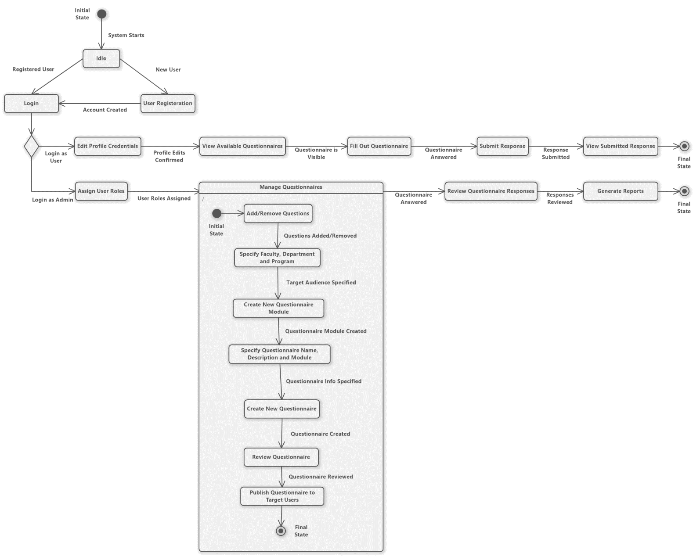

**Figure 19:** State machine diagram for NMU QMS.

### Database Schema

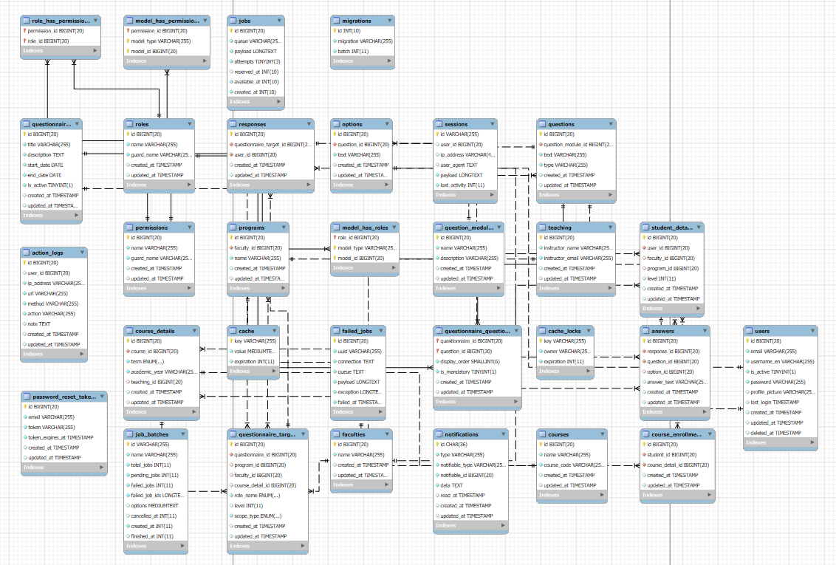

**Figure 20:** Database Schema for NMU QMS.

### Time Plan

**Figure 21:** Time Plan for NMU QMS.

|  |  |  |  |  |
| --- | --- | --- | --- | --- |
| **Concept Dev.** | Project Kickoff | 10/8/24 | 10/16/24 | Blue |
|  | Feasibility Study | 10/16/24 | 10/25/24 | Blue |
|  | Cost Estimates | 10/25/24 | 10/31/24 | Blue |
|  | Rough Prototypes | 10/31/24 | 11/21/24 | Blue |
| **System Design** | Design Architectures | 11/21/24 | 11/28/24 | Red |
|  | Design Sub-systems | 11/28/24 | 12/5/24 | Red |
|  | Refine Designs | 12/5/24 | 12/12/24 | Red |
| **Detail Design** | Tooling | 12/12/24 | 12/19/24 | Green |
|  | Quality Control Def. | 12/19/24 | 12/26/24 | Green |
| **Test & Refine** | Unit Testing | 12/26/24 | 1/4/25 | Brown |
|  | Development Environment | 12/28/24 | 1/7/25 | Brown |
| **Production** | Production Environment | 1/7/25 | 1/26/25 | Orange |
|  | User Guide & Documentation | 1/26/25 | 2/4/25 | Orange |
|  | Data Backup & Recovery Plan | 2/4/25 | 2/18/25 | Orange |
|  | Gain User Feedback | 2/18/25 | 2/28/25 | Orange |
|  | Provide Updates | 2/28/25 | 3/16/25 | Orange |

**Table 4:** Timetable for NMU QMS.

# 4. DISCUSSION

The NMU Questionnaire Management System was developed to address the inefficiencies in creating, managing, and analyzing questionnaires within an academic setting. The system successfully tackles the problems of limited customization, scalability challenges, and security gaps found in existing solutions.

## Addressing the Problem

The primary problem addressed by this project was the lack of an efficient, secure, and scalable platform for questionnaire management at New Mansoura University. The implemented system provides features such as dynamic questionnaire creation, role-based access control, real-time response management, and robust analytics, effectively meeting the identified requirements.

## Significance of Results

The outcomes of the project demonstrate a significant improvement in:

* **Usability**: The intuitive user interface simplifies the process of creating and managing questionnaires, encouraging widespread adoption.
* **Scalability**: The system supports concurrent users and large datasets without performance degradation.
* **Security**: Encryption and role-based access control ensure data integrity and confidentiality.
* **Insights and Analytics**: Advanced reporting capabilities provide actionable insights for administrators and educators.

These results underline the potential for broader adoption of the system within academic and organizational domains.

## Sources of Error and Anomalies

Despite the success, some challenges were encountered:

* **Response Time Variability**: Peak usage periods occasionally resulted in delayed response times, which may require further optimization of backend queries.
* **User Feedback**: Initial usability tests revealed minor navigation issues, which were addressed in subsequent iterations.
* **Integration Limitations**: Compatibility with legacy systems presented some hurdles, necessitating custom integration solutions.

## Broader Impacts and Applications

This project has far-reaching implications for the academic and research domain:

* **Impact**: The system empowers decision-makers with timely and accurate feedback, enhancing academic and administrative processes.
* **Applications**: Beyond academia, this system could be adapted for use in industries requiring large-scale surveys, such as market research and customer feedback.
* **Future Experiments**: Enhancements such as multi-language support, mobile app integration, and machine-learning-based analytics could further increase the system's value.

# 5. CONCLUSIONS

This project set out to design and implement the NMU Questionnaire Management System, a tailored solution to streamline questionnaire management at New Mansoura University.

## Key Findings

The system:

* Addresses the inefficiencies of existing platforms by providing a cost-effective, user-friendly, and secure solution.
* Supports advanced functionalities like dynamic questionnaire creation, real-time analytics, and role-based access control.
* Demonstrates scalability and reliability under various operational conditions.

## Broader Relevance

The findings highlight the relevance of such systems in enhancing data-driven decision-making within academia. This research underscores the importance of customized solutions that cater to specific institutional needs while maintaining adaptability for broader applications.

## Future Directions

Future work could explore the following areas:

* **Multi-language Support**: Expanding the system's accessibility to non-English speakers.
* **Integration with Mobile Platforms**: Developing a mobile app for easier access and increased user engagement.
* **AI-Powered Insights**: Incorporating predictive analytics for deeper insights into response patterns and trends.

In conclusion, the **NMU Questionnaire Management System** represents a significant step forward in addressing the challenges of questionnaire management, paving the way for further innovations in this domain.

# REFRENCES

|  |  |
| --- | --- |
| [1] | Qualtrics, 2024. [Online]. Available: https://www.qualtrics.com/. [Accessed 12 December 2024]. |
| [2] | SurveyMonkey, 2024. [Online]. Available: https://www.surveymonkey.com/. [Accessed 12 December 2024]. |
| [3] | QuestionPro, 2024. [Online]. Available: https://www.questionpro.com/us/. [Accessed 12 December 2024]. |
| [4] | LimeSurvey, 2024. [Online]. Available: https://www.limesurvey.org/. [Accessed 12 December 2024]. |